1. sample packet for a single message on a single line(Row 1,2,3&4)

Ans:









1. checksum calculation based on 16-bit or 8-bit.

Ans:CRC/CCITT(16 bit)

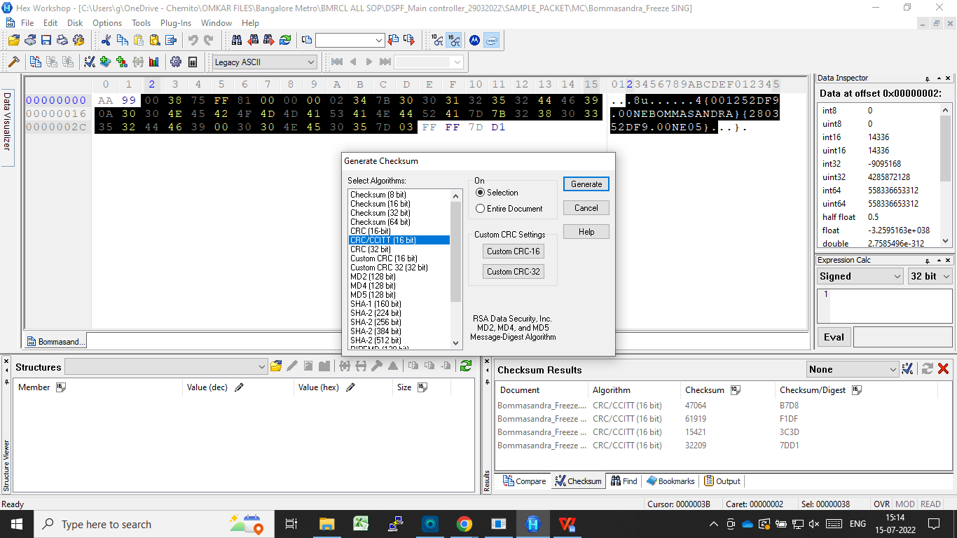

1. Font size and Font type (Bitmap ) for Kannada, English, and Hindi .

Ans: For english language= Font Size -22 or less

Font Type- Chemito English

For regional language= Font Size -16 or less

Font Type- Verdana

1. Maximum size of bitmap like (16\* 240) Matrix size only 16 rows are mention what about column

Ans: (16\* 362)

